**Define SIP Trunk with Avaya:**

On FreePBX Portal, press “Connectivity” and select “Trunks” from options.

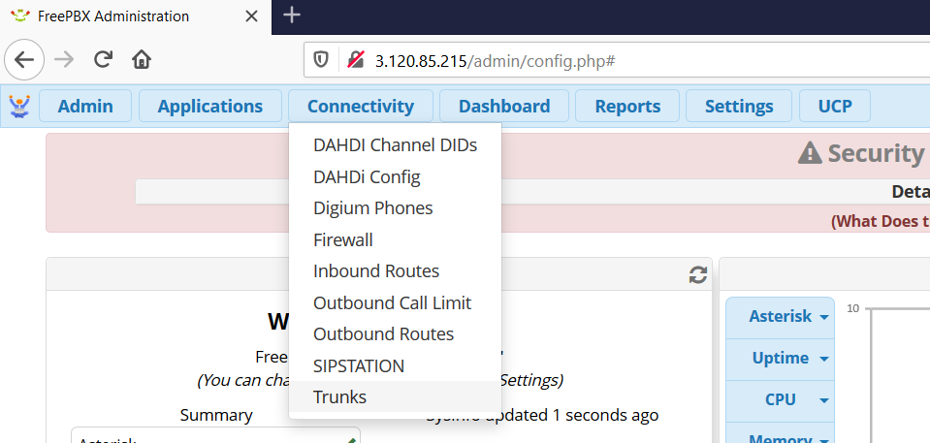

On Trunks page, Press “Add Trunk” and select “Add SIP” option

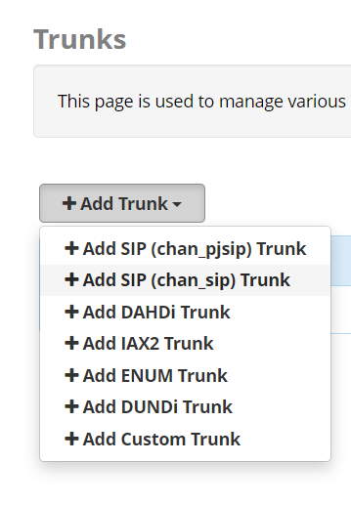

Add General settings:

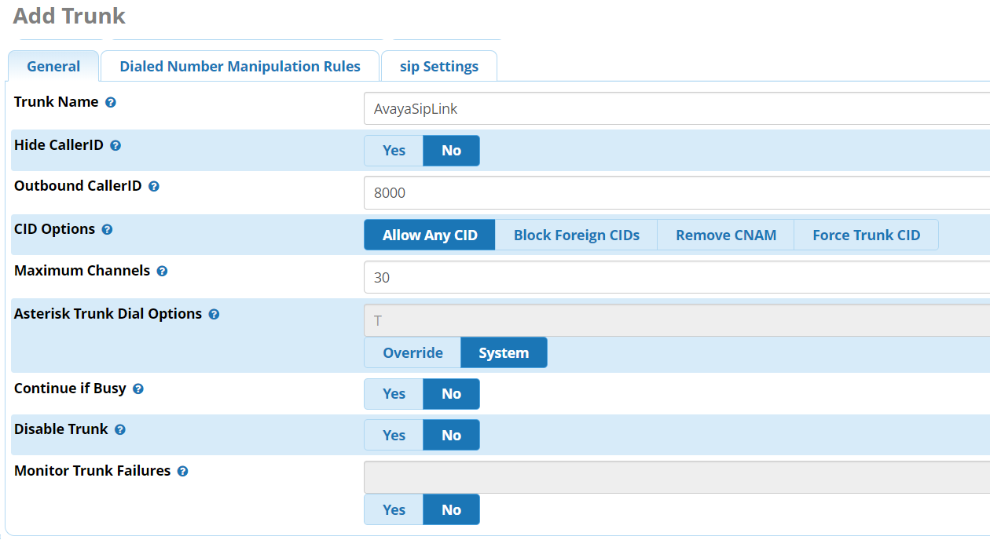

Add Sip Settings:

“host” in sip settings is Avaya IP

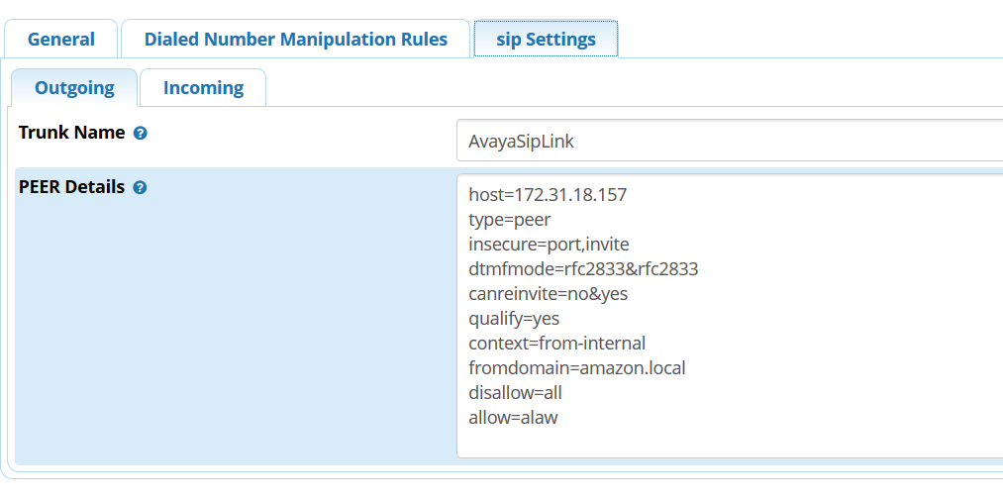

Save the settings.

And your sip trunk is all setup with Avaya.